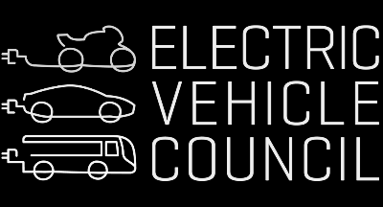 | MEDIA PACK · MAY 2026  ELECTruck  Powering Australia's Trucks with Australian Energy

Published by the Electric Vehicle Council, May 2026. Case studies feature Daimler Truck Australia, IKEA Australia, ANC Delivers, Kempower/JET Charge and Volvo Trucks Australia. International evidence drawn from the UTS-led RACE for 2030 International EV Policy Scan (May 2026).
KEY STATISTICS — AT A GLANCE
$2.10/L  Current diesel price, down from over $3/L in April | $2.55B  Cost of a three-month cut to the fuel excise/road user charge | $4B/yr  Productivity Commission estimate of foregone GDP due to outdated mass limits | $100–150  Per truck, per day — estimated productivity loss from noise restrictions (ANC case study)

15–25%  Estimated productivity uplift from curfew reform (ANC case study) | 45,000 L  Diesel consumed per articulated truck, on average | 630  Approx. number of electric trucks sold in Australia (Truck Industry Council) | 340  Approx. number of electric vans sold in Australia (Truck Industry Council)

0.7%  EV share of heavy vehicle sales in Australia, 2025 (Truck Industry Council) | 53.9%  NEV* share of heavy vehicles sales in China, Dec 2025  *New Energy Vehicles | 4 years  Time to access government incentives for electric trucks in Australia | 4 mins  Time to access government incentives for electric trucks in New Zealand

ABOUT THE REPORT
ELECTruck: Powering Australia's Trucks with Australian Energy is published by the Electric Vehicle Council, May 2026. The report features case studies from Daimler Truck Australia, IKEA Australia, ANC Delivers, Kempower/JET Charge and Volvo Trucks Australia, and Transurban/Linfox. International evidence is drawn from the UTS-led RACE for 2030 International EV Policy Scan (May 2026). The full report is available at https://share-ap1.hsforms.com/1blA3wHr1QBS0laNLWsTVEQdgdkv

Media contact: Todd Hayward | 0412 205 151 | media@evc.org.au | Electric Vehicle Council · May 2026

